Bacis Programming
computing
01, 02, 03, 04, ...10, 11
How count 0, 1
20,99, 100
0, 1, 10, 11, 100, 101, 110, 111
0, 1, 2, 3, 4, 5, 6,7

000000000 byte
kbyte 10000000000
1024
2^12
A,B,C,

65 -A,
65 included !, @#$
ASCIchart.com
Uniconde

Regulartion ?
When build there might be model overfitted ,
1 lassso l1
2. ridge l2
lasso (least Absolute skrinkage and slection operator)
cost=(y-Yi)^2 + lembda|m|
ridge
cost=(y-yi)^2 +lambda*m2

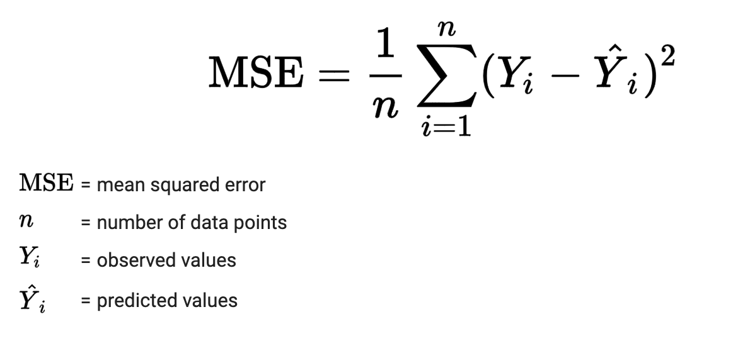

Interview Prepration
story telling
1. untile dive story
Python development
data type
a=’STring”
for i a:
print(i)
b=’How are you”
cont withought
for i in b:
count=0
if i==’o’:
count+=1

